# CTF Challenge: DNS Checker Online Traceroute



# Introduction

In this Capture The Flag (CTF) challenge, you will learn how to use the traceroute utility to understand how data travels across the internet. Traceroute is a network diagnostic tool used to track the pathway packets take from one IP address to another. You'll be using an online traceroute tool to trace the route to a specific domain as traceroute is used for path analysis.

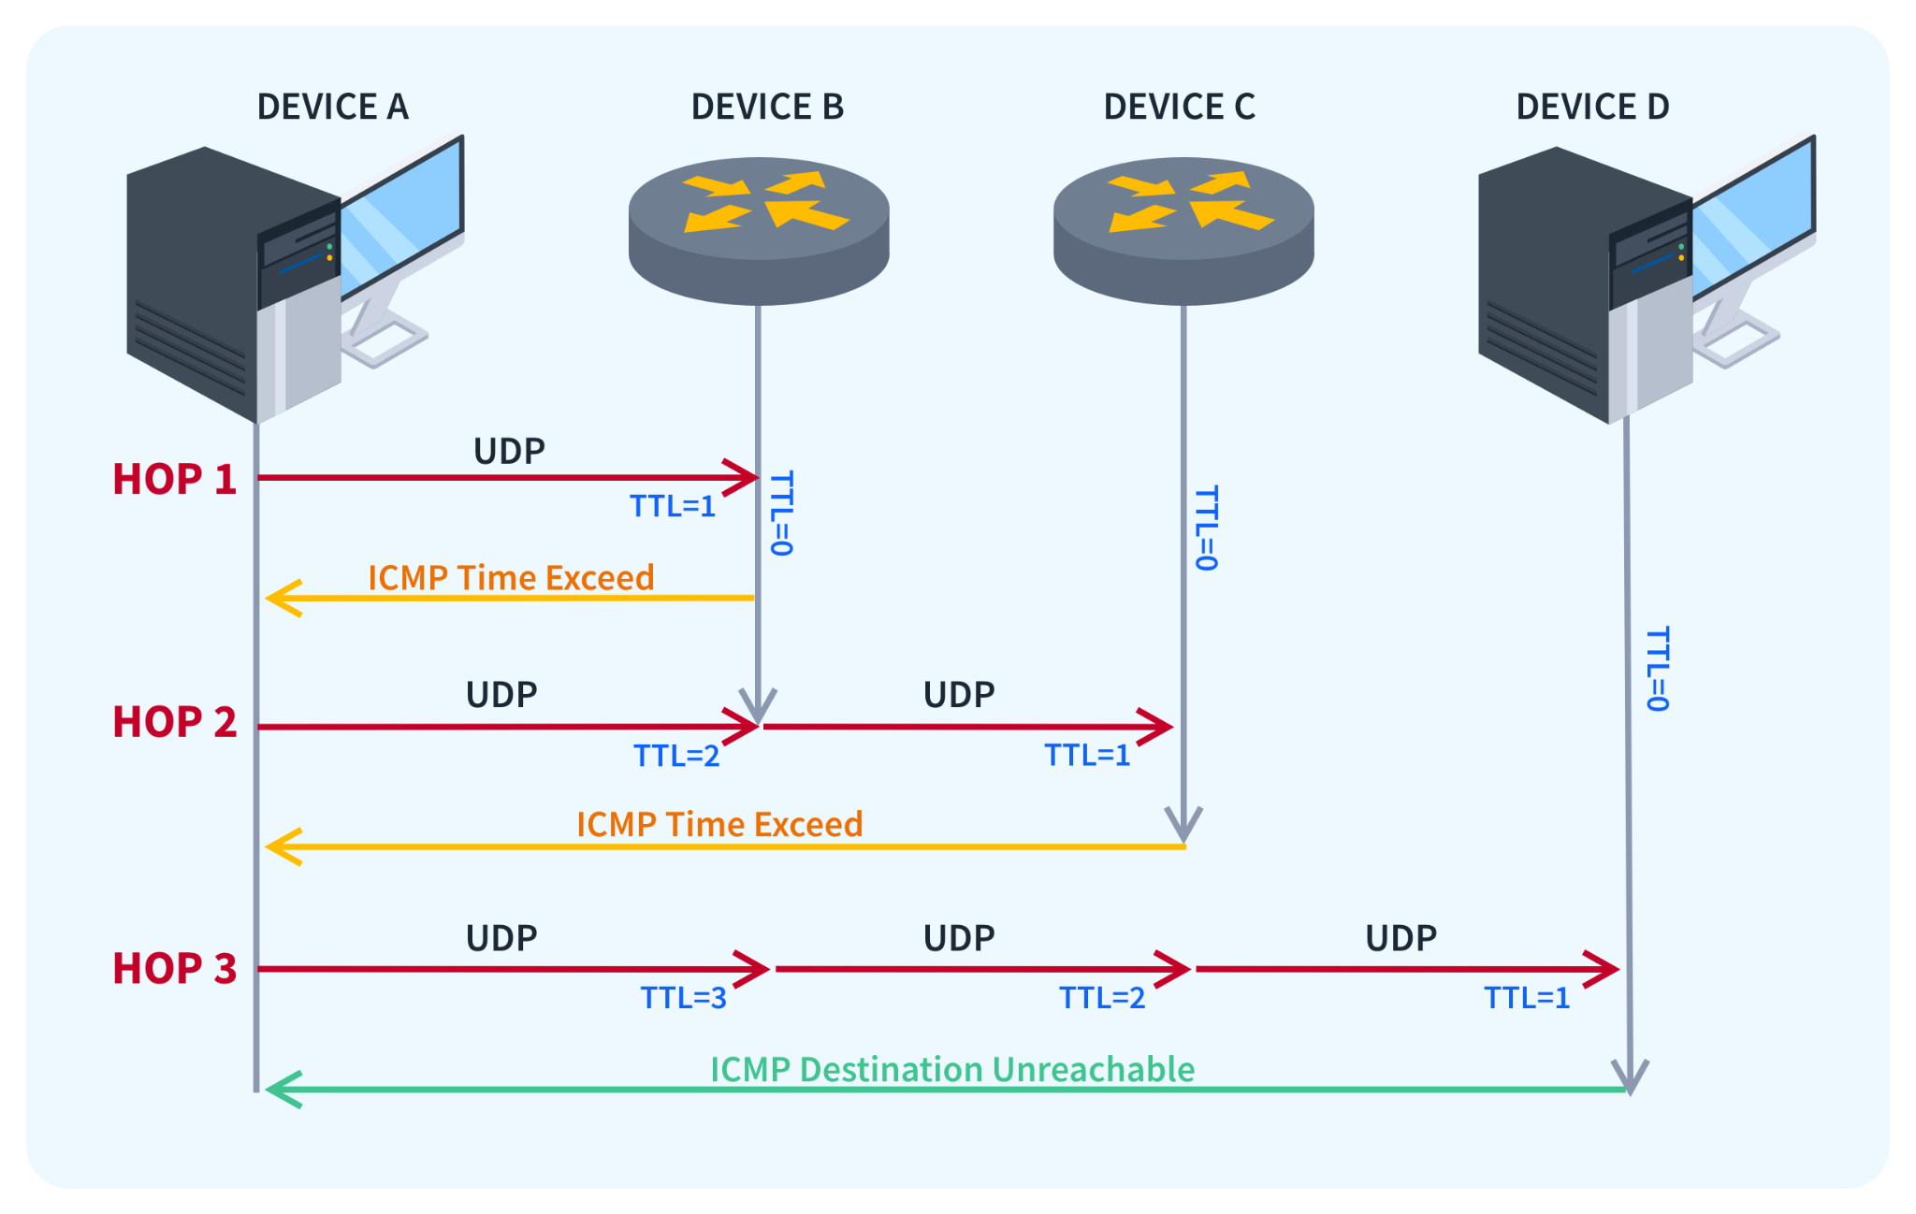

# Challenge Objective

Your objective in this challenge is to use the traceroute tool on DNS Checker to trace the route to a given domain. You'll need to identify the number of hops it takes for the data to reach the destination and gather specific information about the path.

# Tools Required

Online Traceroute Tool: [DNS Checker Online Traceroute](https://dnschecker.org/online-traceroute.php)

# Scenario:



You are a network analyst trying to diagnose connectivity issues to a popular website, google.com. By performing a traceroute, you will map out the path data packets take from your location to the target domain. This information can help identify potential bottlenecks or points of failure in the network.

# Process

1. Access the online traceroute tool: [DNS Checker Online Traceroute](https://dnschecker.org/online-traceroute.php)
2. Enter the target domain: google.com
3. Initiate the Traceroute
4. Observe the results and answer the following questions to capture the flag

# Questions

What is the purpose of traceroute?(Two words answer)

Ans: Path analysis

How many hops does it take to reach the target domain?

Ans: 9 **OR** 10

# Hint

